**User Management in the Jump Server**

Step 1: To generate a public and private key pair using PuTTYgen.

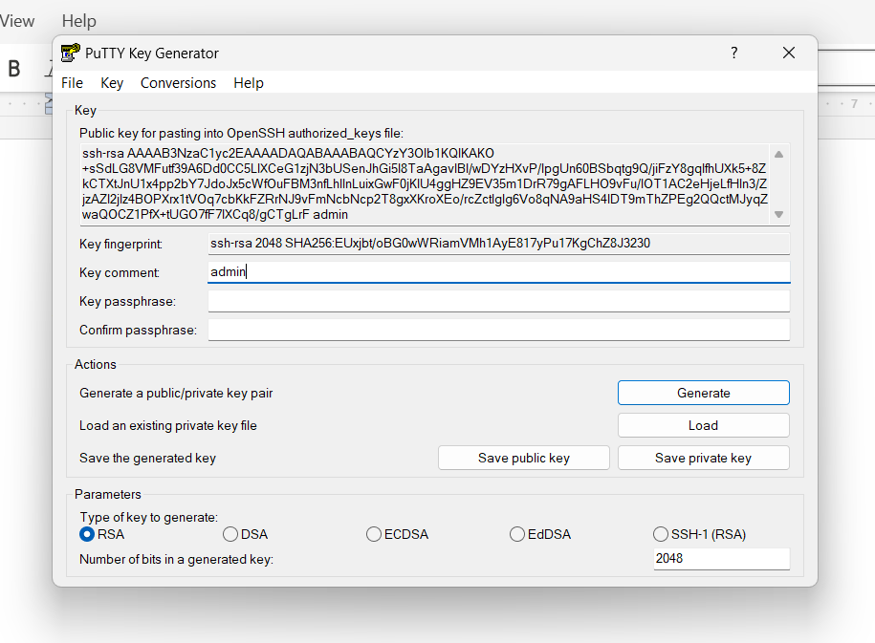Step 2: To save the public and private keys on your system after generating them with PuTTYgen.

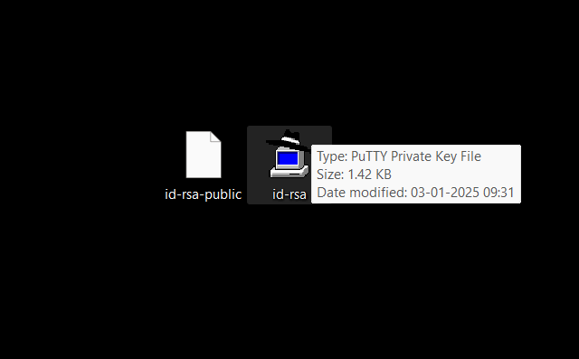

Step 3: To store your public key in the Google Cloud Secret Manager

* Go to Secret manager service in GCP
* Click on create secret
* Give the name of the secret and paste the public in the secret value box as shown in below.

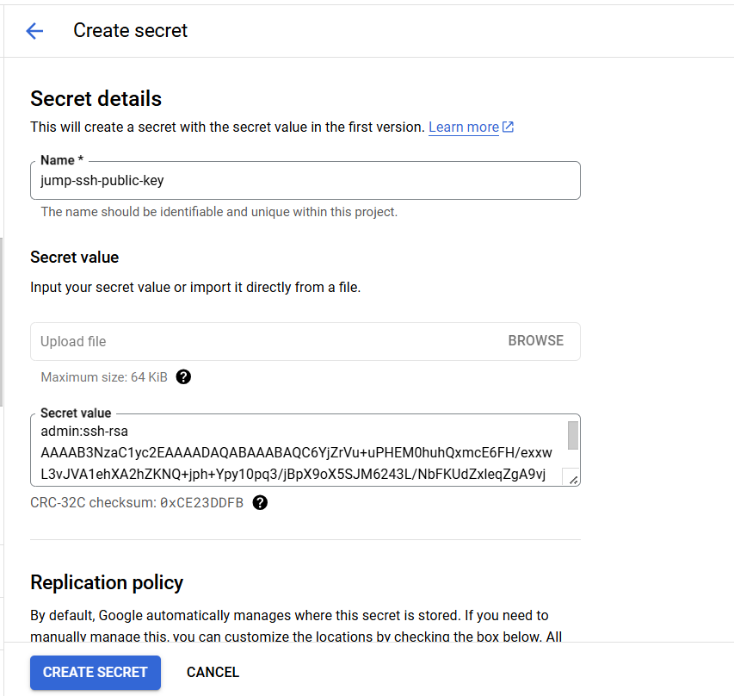

After Secret was created it shows below

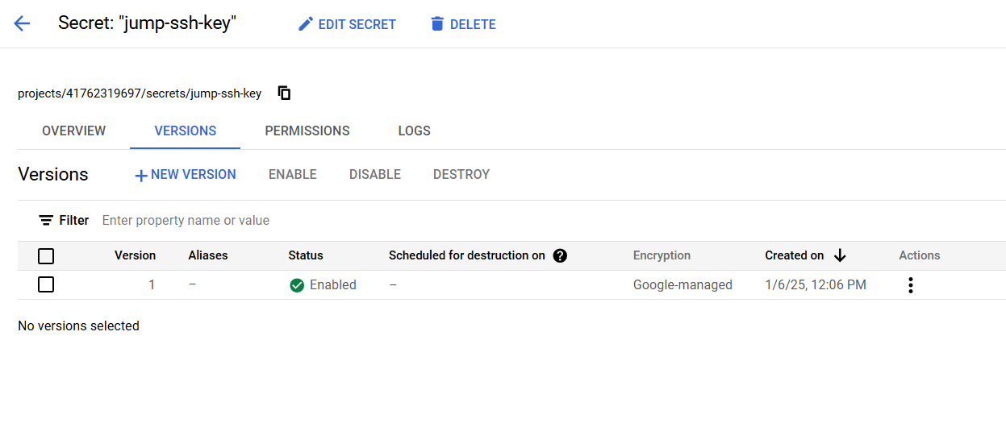

Step 4: Below is the Terraform script that retrieves the secret created earlier from the jump server shown in the below

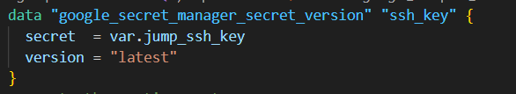

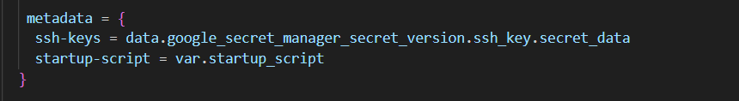

Step 5: After applying the changes with Terraform commands, the jump server is created as shown below.

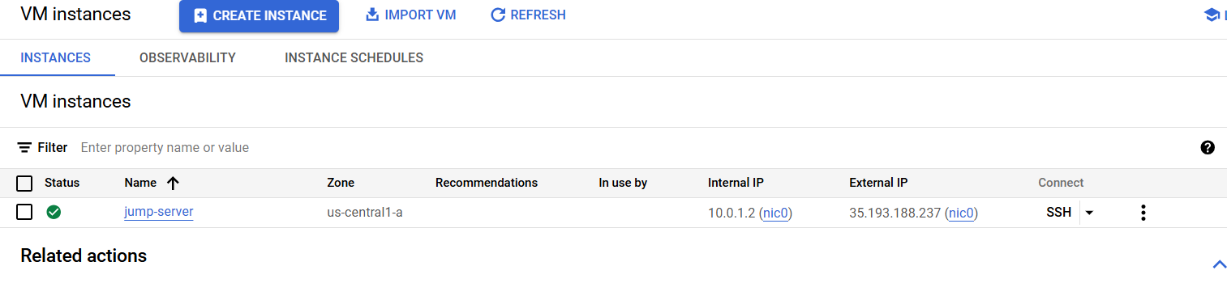

Step 6: Login to the jump server using putty tool.

Take the public Ip address of the jump server and paste in the host name in the putty.

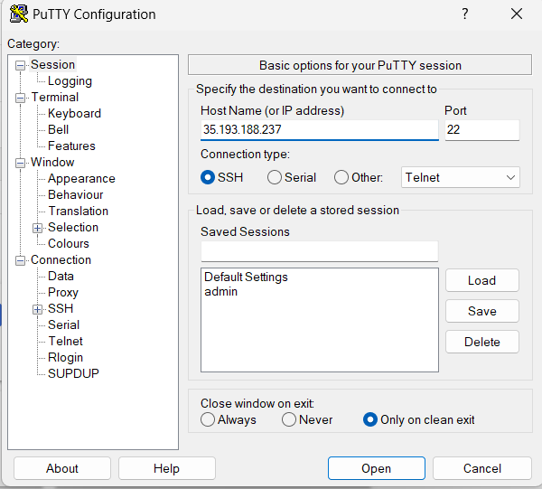

Navigate to SSH -->Auth-->click on Credentials

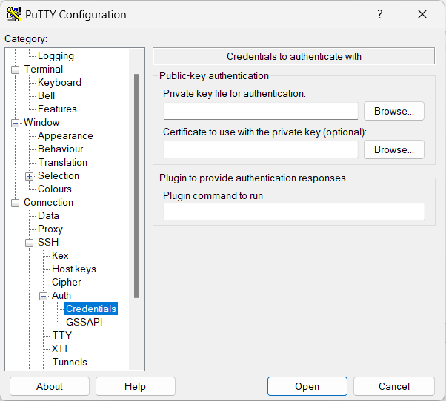

Browser the private key already stored in your system

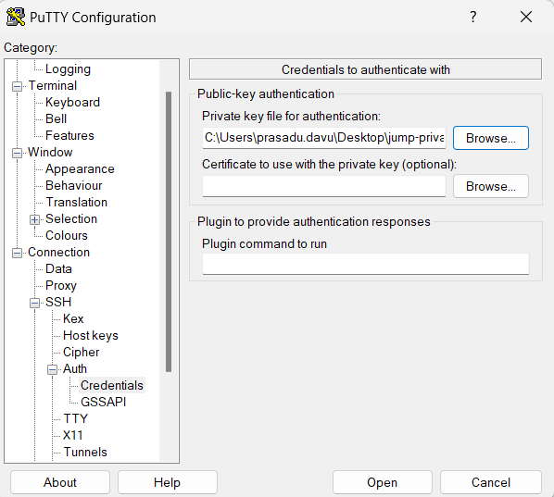

Click on Open Its asking login username --> admin

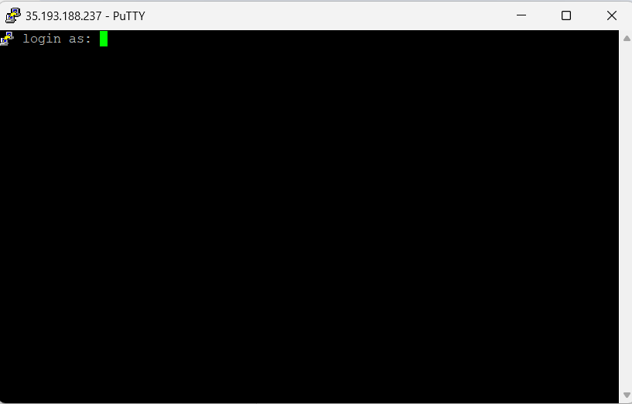Enter admin user after that login to the jump server with admin user.

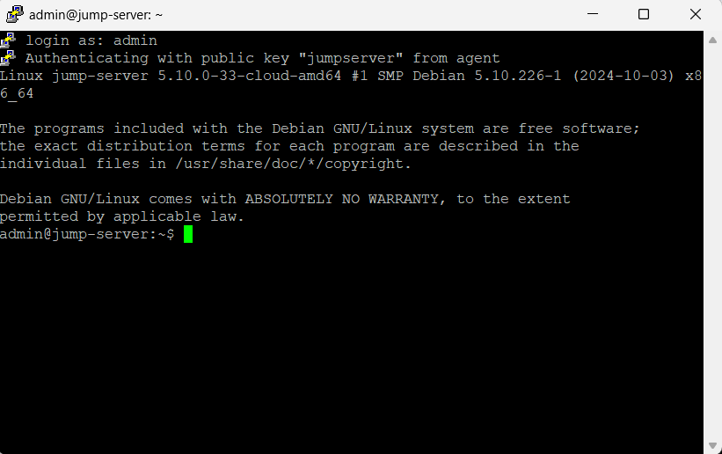

Step 7: Switch to root user using sudo su – command.

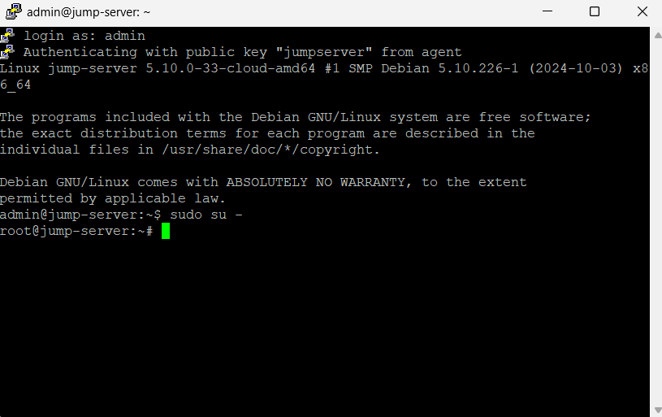

Step 8: Edit the /etc/ssh/sshd_config to enable the password authentication.

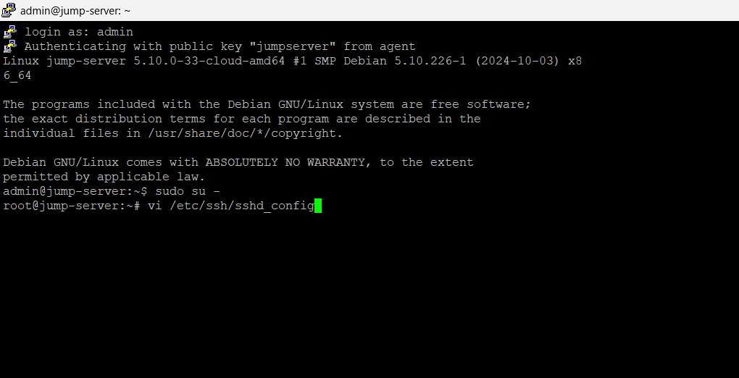

Password authentication is shown in no and edit the yes instead of no.

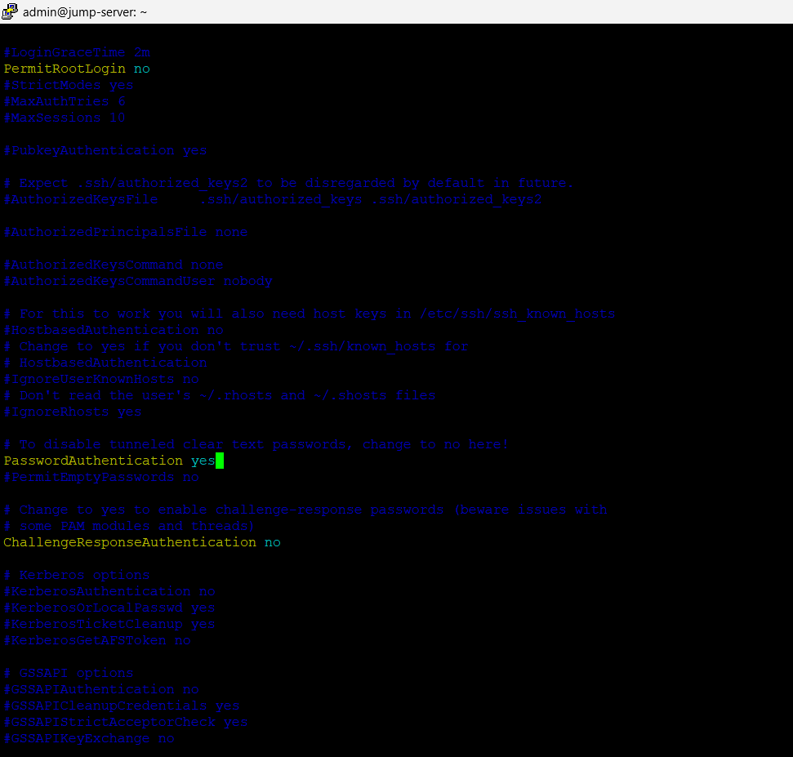After Restart the sshd using systemctl restart sshd command.

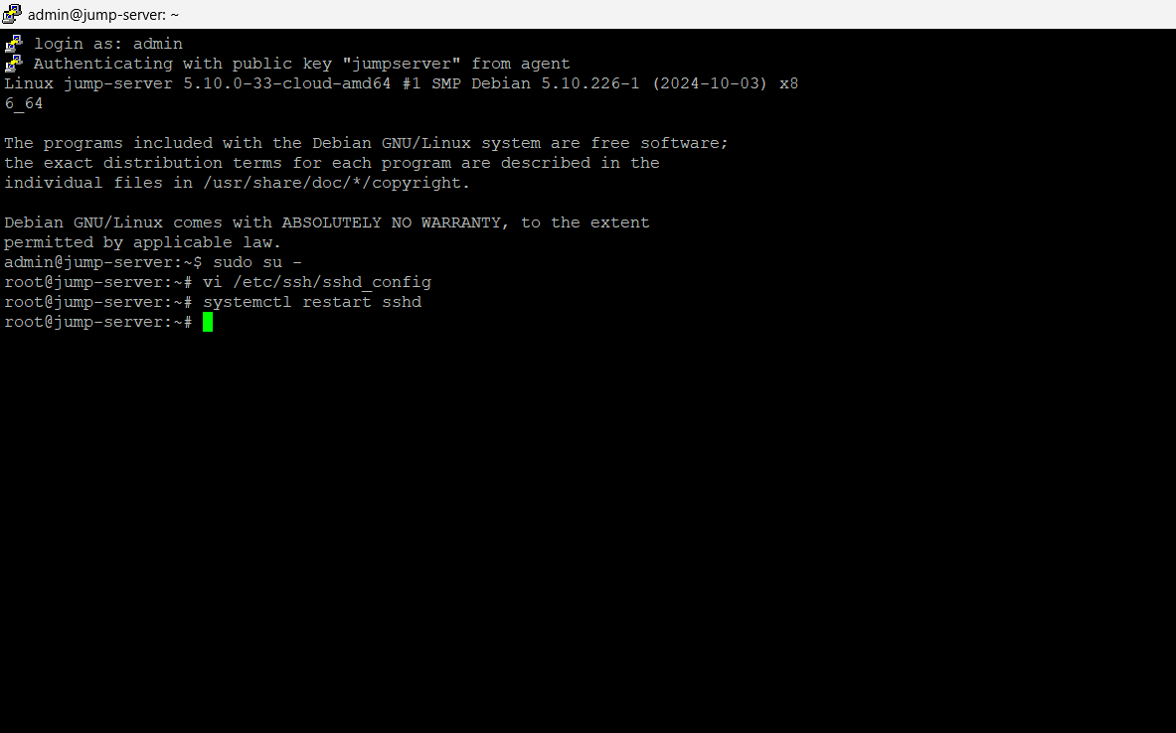

Step 9: Create a new user using adduser command. --> username is Imran

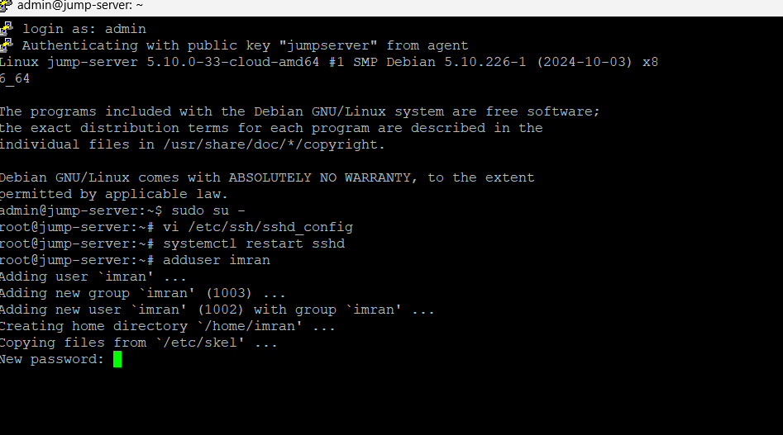The image above prompts for a password. Please enter the password used to access the Jump server.

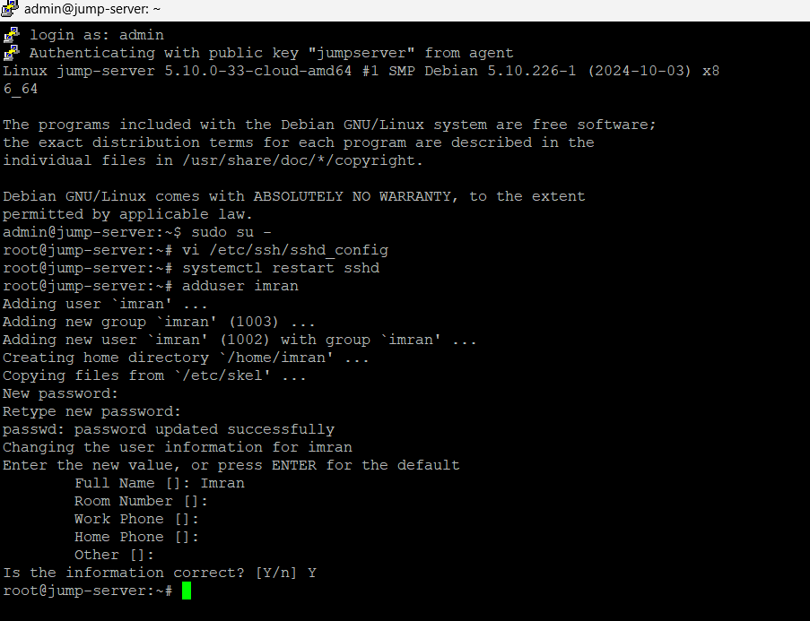Finally user created successfully.

Step 10:

1. Open the PuTTY terminal.
2. Paste the IP address of the Jump server.
3. Navigate to **SSH** > **Auth**.
4. Click on **Credentials**.
5. Follow the steps outlined in step 6.
6. Click on **Open**. When prompted for a login username, enter imran and press Enter.

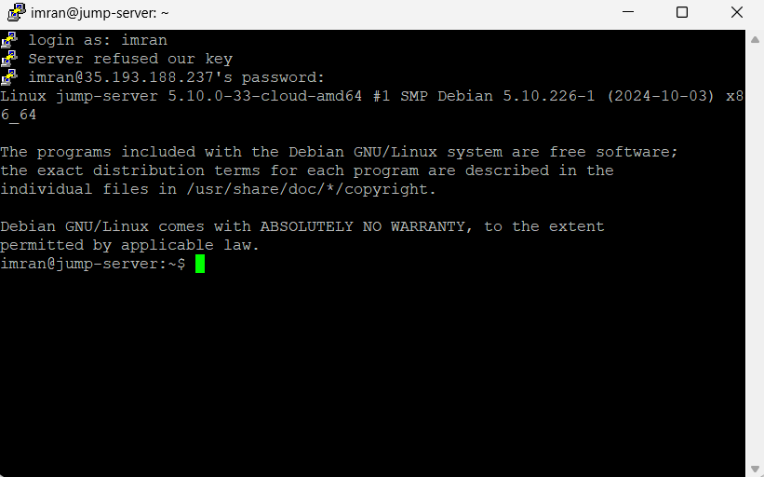

Finally, you have successfully logged in to Imran user in the Jump server.

In this way we can provide Jump server access to different users.